**BCSB Portfolio Alerts System**

Developed by CD

[v2.1.2-prod]

2025-02-09

**Executive Summary**

The Portfolio Alerts system is a portfolio monitoring tool. A quarterly meeting will be held to discuss the portion of the portfolio that is to be reviewed and pushed through the Alerts criteria. This is a way to automate annual reviews for a small subset of the portfolio and provide early warning signs into the deterioration of credit quality. During the quarterly meeting to review the results, the Chief Credit Officer will have authority over the outcomes of each specific loan product that is tested. Team Leaders, Loan Officers, Loan Review, and a designated party to take minutes will be required to attend. It will only be use on a segment of the portfolio, specifically: Lines of Credit under $500M and below $1MM in total relationship exposure.

**Deliverables**

**System Overview:**

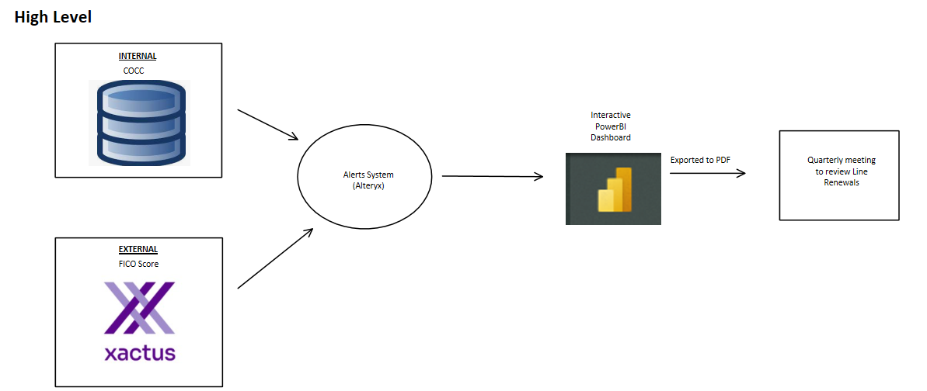

The process map below shows the five distinct outcomes for each product at the quarterly alerts meeting.

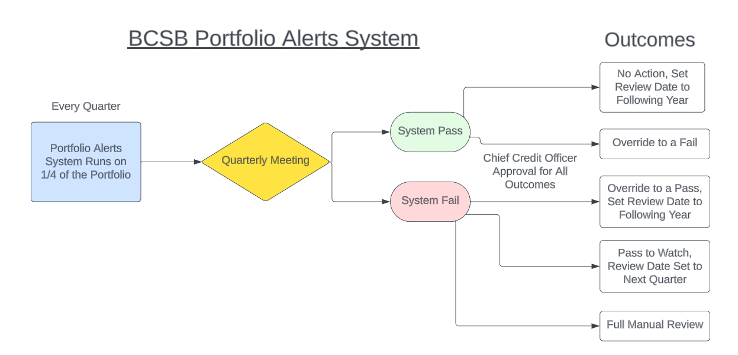

In no particular order, the outcomes for each item reviewed at the quarterly meeting are as follows:

1. System Pass, No Action
   1. If there are no warning signs, this is the default course of action
   2. This will be documented and placed in the Credit File
   3. The review date is set to next year.
2. System fail
   1. A full manual review is required to renew the line.
   2. This needs to be completed within 90 days (otherwise it would fail next quarter again)
3. System fail, but override pass
   1. This can only be done by CCO
   2. Several criteria had failed, but this will be overridden and the item in question will pass and have the review date set to next year.
   3. This will be discussed and should be explicitly noted in the minutes
4. System fail, watch until next quarter/semi-annual
   1. Essentially, this is a pass to watch
   2. The review date is set to next quarter
   3. FICO score will be soft pulled again
5. System pass, but officer overrides to fail
   1. This will be rare, but may occur if officer has some information that is not reflected in the data
   2. Could be a pass-watch or initiates a full manual review

**Criteria:**

* ***Deposit Decrease****:* Check if average deposit balance for the relationship over trailing 3 months has declined by 30% or greater when compared to trailing 12 month average balance. Relationships with total deposits <= $250,000 are excluded from this test (to exclude flagging accounts where deposits decrease from $10,000 to $7,000 for example).
* ***Past Due:*** Check if the account has been past due 15-29 days 3x or more within the trailing 12 months or 30+ days 1x over the same period.
* **TTM Overdrafts:** Check on COCC if there have been more than 5 overdrafts in any deposit accounts in the relationship in the trailing 12 months. The measure is the days overdrawn statistic from COCC.
* ***TTM Utilization:*** Assess whether line utilization has been greater than 70% over the previous 12 months.
* ***30-Day Cleanup Provision:*** Check on COCC if the line has been paid to 0 for at least 30 days. If yes, the screening will continue.
* ***FICO:*** Check if any of the guarantors on the account have a FICO score < 680 or if the current credit score has decreased 10% vs the credit score in the prior period.